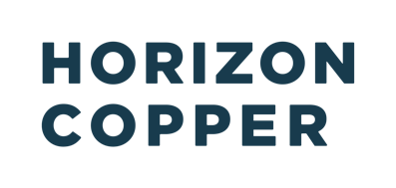

Horizon Copper Corp.

Symbol: TSXV: HCU | OTCQX: HNCUF
Market Cap: 59M
Sector: Mining | Copper
Purpose: Raise Awareness / Open Market Buying

Horizon Copper is a premier copper company holding a portfolio of unparalleled copper assets including a 1.66% net profits interest on the Antamina copper mine, exposure to the Oyu Tolgoi copper mine through a 24% equity ownership in Entrée Resources Ltd., and a 30% interest in the copper-gold Hod Maden project. Horizon plans to actively grow its portfolio of assets with a focus on copper projects.

Investor Bullet Points:

- Diversified portfolio of non-operating interests in low-cost, high-quality copper mines

- Cash-flowing assets today, with growing cash flows levered to copper prices

- Significant growth built-in and financing flexibility for future acquisitions

Erfan Kazemi – President & CEO

Erfan Kazemi brings years of experience to Horizon Copper. Since 2011, Mr. Kazemi has helped raise over a billion dollars in equity and debt financing in his role as Chief Financial Officer at Sandstorm Gold Royalties. He has played a critical role in the success of Sandstorm’s royalty investments through his responsibilities on the corporate development front and the company’s investment committee. Erfan is a Chartered Professional Accountant (CA), a Chartered Financial Analyst charter holder, and a graduate of the University of British Columbia with a Bachelor of Science degree in Mathematics.

