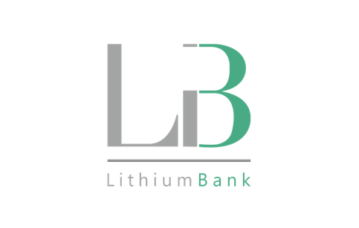

LithiumBank Resources Corp.

Symbol: TSXV: LBNK | OTCQX: LBNKF
Market Cap: 31M
Sector: Mining
Purpose: Raise Awareness / Open Market Buying

LithiumBank Resources Corp. is an exploration and development company focused on lithium-enriched brine projects in Western Canada where low-carbon-impact, rapid DLE technology can be deployed. LithiumBank currently holds over 3.2 million acres of mineral titles, 2.82M acres in Alberta and 326K acres in Saskatchewan. LithiumBank’s mineral titles are strategically positioned over known reservoirs that provide a unique combination of scale, grade and exceptional flow rates that are necessary for a large-scale direct brine lithium production. LithiumBank is advancing and de-risking several projects in parallel of the Sturgeon Lake Lithium Brine Project.

Investor Bullet Points:

- In Q2/2021 Apex Geoscience produced a Ni 43-101 inferred resource for Sturgeon Lake
  - The report inferred a 5.97M tonne/LCE resource
  - Avg grade of 67.1mg/L
  - One of the largest known contiguous potentially carbon-neutral inferred lithium brine resources in North America.

- Hatch engineering was contracted in H2/21 to produce a preliminary economic assessment (PEA) for Sturgeon Lake(now called the Board Walk Project) by mid-2022

- LithiumBank holds 3.15 million acres of highly prospective Mineral titles in Alberta & Saskatchewan.
  - 2.82M acres in Alberta (flagship project: Sturgeon Lake)
  - 0.33M acres in Saskatchewan.
  - Of note, their neighbour in Saskatchewan, Prairie Lithium, is marketing a $40M raise on a ~$100M pre-money valuation round.
  - LithiumBank expects to produce a Ni 43-101 inferred resource in Saskatchewan in Q4 2022.

Rob Shewchuk, Chairman & CEO

Alberta based investor with 25 years experience in the capital markets including Chairman of Standard Securities Capital Corp and Managing Director of Wolverton Securities Ltd acquired by PI Financial Corp in 2016. Rob currently serves on the Board of Directors of Graphene Manufacturing Group Pty Ltd, Spectre Capital Corp, Verses Technologies Inc and is a Partner and Director at Caerus Capital Partners Inc.

