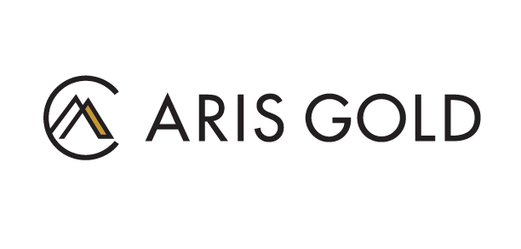

Aris Gold Corporation

Symbol: TSX: ARIS | OTCQX: ALLXF
Market Cap: 223M
Sector: Mining | Gold
Purpose: Raise Awareness / Open Market Buying

Aris Gold is a Canadian mining company listed on the TSX under the symbol “ARIS”. Aris Gold is led by an executive team with a demonstrated track record of creating value through building globally relevant gold mining companies. The company operates the Marmato mine, where a modernization and major expansion program is under way, and the world class Soto Norte project in Colombia. The Company is also advancing the Juby exploration project in the Abitibi Greenstone belt of Ontario, Canada.
Investor Bullet Points:
- Delivering on a proven buy and build strategy and backed by a team of industry leaders including former Goldcorp Chair Ian Telfer, Aris Gold is building a diversified, globally relevant gold producer
- We operate the Marmato gold mine in Colombia, where a major expansion is under way
- We have a the right to acquire a 50% interest in the Soto Norte project, also in Colombia, one of the world’s largest and highest grade gold development projects
- We also own the Juby advanced exploration project in Canada’s prolific Abitibi belt

Tyron Breytenbach, SVP Capital Markets

Tyron Breytenbach is a former equity analyst at Cormark Securities and Stifel Canada where he interacted extensively with the international investment community. Prior to joining Aris Gold in 2022, Mr. Breytenbach was a Senior Partner and Managing Director in the investment banking group at Canada’s largest employee-owned dealer. Prior to entering capital markets, Mr. Breytenbach spent a decade in the mining industry as a geologist where he focused on orogenic and epithermal gold deposits and specialized in resource estimation. Mr. Breytenbach holds a BSc (Honours) Degree from Rand Afrikaans University in South Africa and is a designated P.Geo in Ontario.

