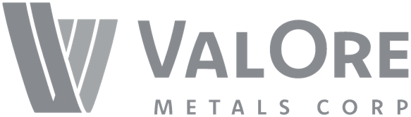
ValOre Metals Corp.

Symbol: TSXV: VO | OTCQB: KVLQF
Market Cap: 53M
Sector: Mining
Purpose: Raise Awareness / Open Market Buying

ValOre Metals Corp. is a Canadian company with a portfolio of high‐quality exploration projects. ValOre’s team aims to deploy capital and knowledge on projects which benefit from substantial prior investment by previous owners, existence of high-value mineralization on a large scale, and the possibility of adding tangible value through exploration, process improvement, and innovation.

Investor Bullet Points:

- Highest grade uranium resource in the world outside of the Athabasca Basin: 43.3 million pounds of U3O8 grading 0.69% (NI 43-101 resource)
- Ownership of entire PGE district in Brazil, 1.067 Moz 2PGE+Au (NI 43-101 compliant resource)
- $11 million in the treasury to be spent this year on exploration and development

Jim Paterson – Chairman & CEO
Jim is a principal of Discovery Group and has been actively involved in marketing and corporate development activities for the group companies since 2002. Jim has 23 years of industry experience, including capital raises, acquisitions, joint-ventures, spin-outs, RTOs, and IPOs.

Jim was a long-standing and active director of Kaminak Gold Corp. (acquired by Goldcorp) and founding director of Northern Empire Resources Corp. (acquired by Coeur Mining). In 2007, Jim founded Corsa Capital Ltd. Corsa’s 2008 IPO lead to a 2010 transaction which created a leading U.S. metallurgical coal producer with a C$250M market capitalization.

Colin Smith – VP Exploration
Colin Smith is a registered Professional Geologist (P.Geo.) in British Columbia, Saskatchewan, Nunavut and the Northwest Territories with over 16 years experience developing, executing and managing exploration campaigns in North and South America, ranging from early-stage project generation to near-mine resource delineation. Colin has garnered him a technical expertise with structurally hosted gold, ultramafic-associated PGEs, porphyry copper-gold, diamonds, unconformity-related uranium, and coal.

