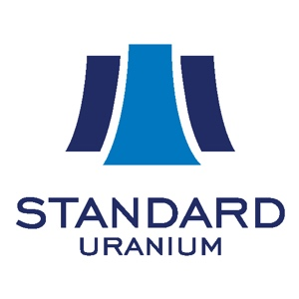

Standard Uranium Ltd.

Symbol: TSXV: STND | OTCQB: STTDF
Market Cap: 15M
Sector: Mining
Purpose: Raise Awareness / Open Market Buying

Standard Uranium is a Canadian junior uranium exploration company looking to make the next big discovery in the Athabasca Basin region of northern Saskatchewan, Canada. With a proven track record of high-grade uranium discovery, our Company's exploration team is focused on finding the fuel to power a clean energy future. Our flagship Davidson River Project is located in the heart of the Patterson Lake Uranium District in the southwest Athabasca Basin, an area ripe with potential for futher uranium discoveries. With only a handful of holes drilled on the Project, we have only just begun to scratch the surface of what the property holds. The Company will continue advancing aggressive drilling campaigns on the Davidson River Project as we search for the next big Canadian uranium discovery - building towards our clean energy future.
Investor Bullet Points:

- Flagship Davidson River Drill program started May 16 - News release will be out on 16th.

- Financing for exploration coming soon

Jon Bey, CEO
Mr. Bey is a capital markets executive with over 13 years in the junior exploration industry with experience in uranium, gold, silver, lead, zinc, diamonds and oil and gas. He has public company experience across several sectors and with companies listed on the TSX, TSX-V, CSE, and LSE Exchanges. Mr. Bey is the founder and Managing Director of the Steel Rose Group of companies.

Sean Hillacre, VP Exploration
Mr. Hillacre has 5 years’ experience working as an exploration geologist in the Athabasca Basin uranium district in Saskatchewan working as part of the technical team progressing the Arrow uranium deposit towards production with NexGen Energy. A high-energy, results oriented geoscientist, Mr. Hillacre brings a unique and balanced background integrating academic geoscience with industry experience, along with a comprehensive understanding of project development. Mr. Hillacre received his B.Sc. & M.Sc. degrees in Geology from the University of Saskatchewan.

