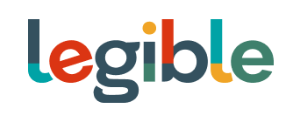

Legible Media Inc.

Symbol: TSXV: READ | OTCPK: LEBGF
Market Cap: 7M
Sector: Tech-Publishing
Purpose: Market Awareness / Open Market Buying

Legible is a browser-based eBook reading platform that is revolutionizing how readers, publishers, and authors connect. Informed by a design-forward and value-centric ethos, Legible’s innovative technology offers readers across the globe open access to millions of books through any internet-connected device. Legible is rooted in core values of sustainability, accessibility, beauty, and integrity.

Investor Bullet Points:

- TRANSFORMATIONAL - Transformational Browser-Based Mobile-First eBook Reading and Publishing Platform

- GLOBAL - Beautifully Rendered eBooks Accessible to Book Lovers All Over the World/INDUSTRY EXPERTS - A Global Platform Led by a Team of Publishing Industry Insiders

- SOCIALLY RESPONSIBLE - Supporting Literacy Efforts Around the Globe

- VALUES - Beauty, Accessibility, Sustainability, Integrity

- VISION - To Become the Internet of Books

Kaleeg Hainsworth, Chairman, Founder & CEO
Three decades of technology, publishing, and leadership experience across a wide range of business and organizations. Kaleeg is a globally recognized leader in the digital publishing industry, and the founder of asuccessful national ebook and digital production company, providing assets to publishers internationally for over ten years.

