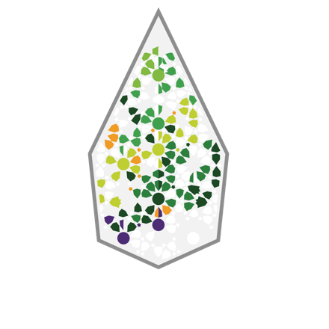

Avicanna Inc.

Symbol: TSX.V: AVCN | OTCQX: AVCNF
Market Cap: 35.9M
Sector: Cannabis
Purpose: Raise Awareness / Open Market Buying

Avicanna is a Canadian biopharmaceutical company providing the global marketplace with advanced natural cannabinoid solutions through an evidence-based approach offered across several product platforms including API, medical, pharmaceutical, and dermacosmetic. As a multinational organization with vertical integration, Avicanna is focused on utilizing the scientific research related to plant-derived cannabinoid products through its internal research platforms and strategic collaborations with world-class research institutions.
Investor Bullet Points:
- Avicanna is a Canadian cannabinoid bio-pharmaceutical company with industry leading scientific platform including R&D, pre-clinical and clinical infrastructure

- Commercial stage including a partnership with Shoppers Drug Mart for RHO Phyto branded medical products across Canada and Pura branded CBD skin care products across several markets

- Vertically integrated and low-cost supply chain in Colombia to supply the companies’ commercial products and pharmaceutical pipeline

Aras Azadian, Founder & CEO

Utilizing his extensive senior management experience in both financial and bio-technology sectors, Aras co-founded Avicanna with the vision of establishing a bio-pharmaceutical company with a strict focus on medical and pharmaceutical applications of cannabinoids. His expertise in corporate development coupled with his executive experience in the oncology industry have been integral to Avicanna’s thought leadership pertaining to R&D and clinical development. Since 2016 Aras has successfully led a team of executives, scientists and medical professionals across several countries with the vision of vertical integration and a strong company focus on quality controls, scientific vigour and competitive advantages. Aras holds a Bachelor of Economics degree from York University and an International Masters in Management degree from EADA Business School in Barcelona, Spain.

